# Target Metrics

Overall - Accuracy: 0.5000, Precision: 0.6578, Recall: 0.5000, F1: 0.5450

Class-specific metrics:

Carbon neutral(ity) - Precision: 0.8889, Recall: 0.3200, F1: 0.4706

Emissions reduction target - Precision: 0.7600, Recall: 0.7600, F1: 0.7600

N/A - Precision: 0.0000, Recall: 0.0000, F1: 0.0000

Net zero - Precision: 0.7917, Recall: 0.7600, F1: 0.7755

No target - Precision: 0.1905, Recall: 0.1600, F1: 0.1739

# Year Metrics

Overall - Accuracy: 0.7000, Precision: 0.7785, Recall: 0.7000, F1: 0.6991

Class-specific metrics:

2020 - Precision: 0.0000, Recall: 0.0000, F1: 0.0000

2022 - Precision: 0.0000, Recall: 0.0000, F1: 0.0000

2025 - Precision: 1.0000, Recall: 0.4000, F1: 0.5714

2030 - Precision: 0.7826, Recall: 0.7200, F1: 0.7500

2031-32 - Precision: 0.0000, Recall: 0.0000, F1: 0.0000

2031.3 - Precision: 0.0000, Recall: 0.0000, F1: 0.0000

2032 - Precision: 0.0000, Recall: 0.0000, F1: 0.0000

2033 - Precision: 0.0000, Recall: 0.0000, F1: 0.0000

2035 - Precision: 0.6667, Recall: 0.8000, F1: 0.7273

2040 - Precision: 1.0000, Recall: 0.8000, F1: 0.8889

2050 - Precision: 0.9286, Recall: 0.4815, F1: 0.6341

No target - Precision: 0.5952, Recall: 1.0000, F1: 0.7463

Not applicable - Precision: 0.0000, Recall: 0.0000, F1: 0.0000

# Other Metrics

Quote Accuracy: 0.4100

Overall Accuracy: 0.4200

Valid XML Percentage: 1.0000

# Confusion Matrices

Target Confusion Matrix:

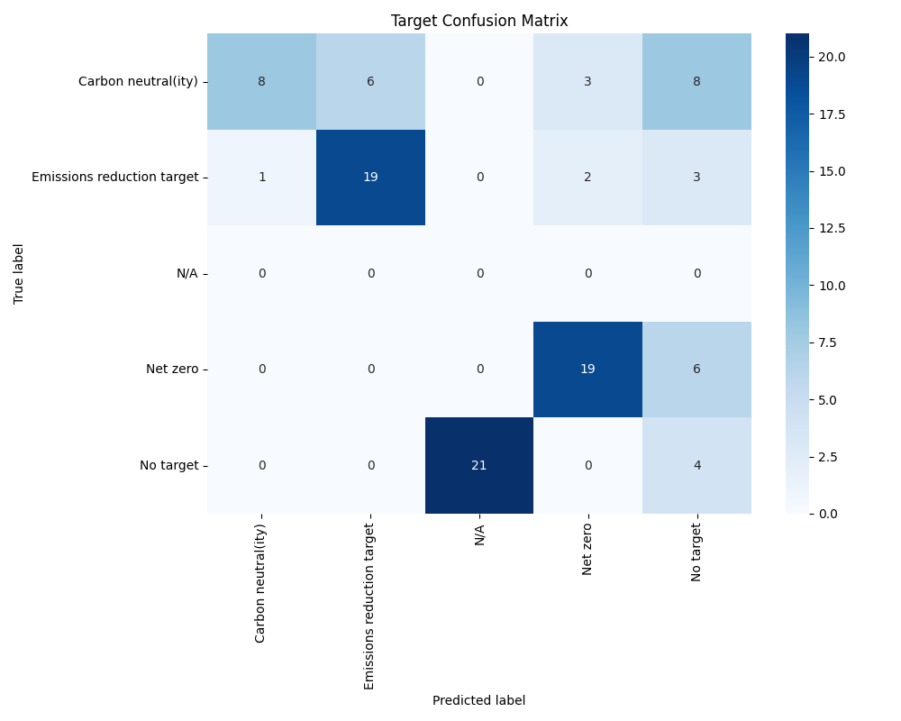

Year Confusion Matrix:

